Disease Risk Prediction System

Project Id: PY-QT-65

Name : Samarth Tomer (Team Leader)
Class Roll Number: 65
University Roll Number : 2028834
Section and Group: Q G2

Name : Sparsh Saxena
Class Roll Number: 70
University Roll Number : 2028864
Section and Group: Q G2

Name : Tanmay Kumar
Class Roll Number: 72
University Roll Number : 2028879
Section and Group: Q G2
TABLE OF CONTENTS
- Problem Description 3
  - Dataset Description 3
  - Flow diagram 4
- Modules for Project Implementation…………………..…………………………5
  - Modules Used 5
  - Platform Used 6
- Machine Learning model/ Searching Technique used 7
- Evaluation metrics used 8
- Results and Visualizations 9
- Conclusion and Future Scope 11
- References 12

- Problem Description

The Disease Risk Prediction System is a machine learning-based classification project designed to predict the likelihood of heart disease in patients using clinical data.
The system uses a dataset containing various medical attributes such as age, sex, chest pain type, blood pressure, cholesterol level, maximum heart rate, and other diagnostic measurements. Two datasets were used in this project: a raw dataset and a cleaned dataset after preprocessing.
The objective of this project is to build predictive models that can classify whether a patient is at risk of heart disease (target = 1) or not (target = 0).
To ensure high-quality predictions, the system performs:
- Data cleaning to handle missing and inconsistent values
- Data transformation and normalization for better model performance
- Feature selection to identify the most important medical attributes
Three machine learning algorithms — Logistic Regression, K-Nearest Neighbours (KNN), and Support Vector Machine (SVM) — are trained and compared.
The models are evaluated using performance metrics such as accuracy, precision, recall, F1-score, confusion matrix, and ROC curve.
This system can assist in early detection of heart disease and support medical decision-making using data-driven insights.

1.1 Dataset Description
The dataset used in this project is heart_disease_prediction_raw.csv, which contains medical and lifestyle attributes of patients used to predict the presence of heart disease.
Key Features:
- Age
- Gender
- Chest Pain Type
- Resting Blood Pressure
- Cholesterol
- Fasting Blood Sugar
- Resting ECG
- Maximum Heart Rate
- Exercise-Induced Angina
- Slope
- Thalassemia
- Target Variable: heart_disease (0 = No, 1 = Yes)
Preprocessing Steps Performed:
- Removal of duplicate records
- Handling missing values (mode for categorical, median for numerical)
- Dropping irrelevant column (id)
- Standardizing categorical values (e.g., m → male)
- Encoding categorical variables (Label encoding + One-hot encoding)
- Outlier removal using IQR method
- Feature scaling using StandardScaler
1.2 Flow Diagram

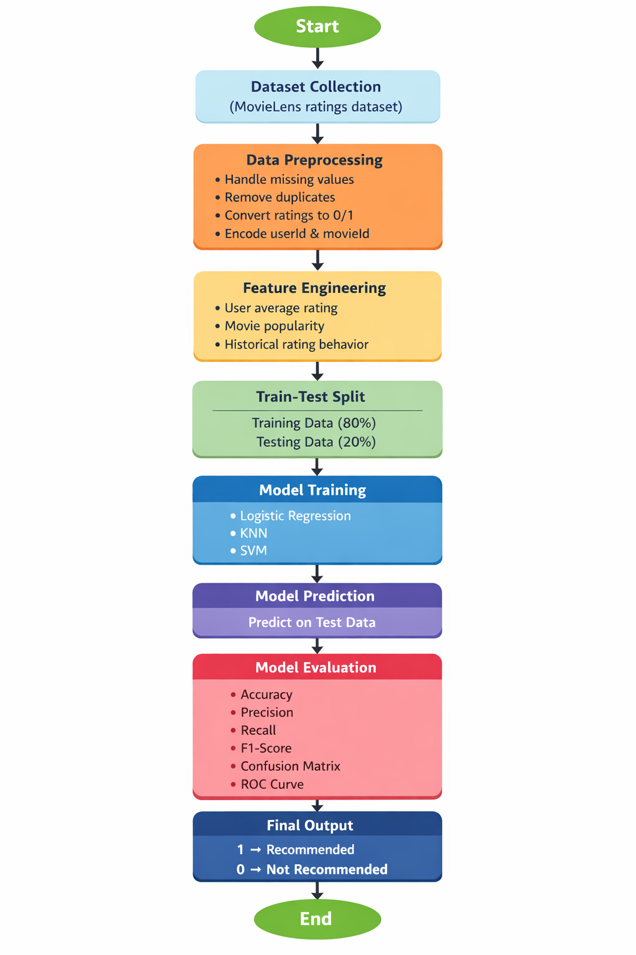
Fig.1 Sample flow diagram.

Modules for Project Implementation

2.1 Modules Used
- NumPy – Used for numerical computations and array operations.
Functions: np.abs, np.argmin
- Pandas – Used for data manipulation and analysis.
Functions: pd.read_csv, drop, fillna, get_dummies
- Matplotlib – Used for data visualization.
Functions: plt.figure, plt.subplot, plt.show
- Seaborn – Used for statistical data visualization.
Functions: sns.boxplot
- Scikit-learn (sklearn) – Used for machine learning tasks:
  - Model Selection: train_test_split
  - Preprocessing: StandardScaler
  - Models:
    - Logistic Regression
    - K-Nearest Neighbors (KNN)
    - Support Vector Machine (SVM)
  - Metrics:
accuracy_score, precision_score, recall_score, f1_score, confusion_matrix, roc_auc_score

2.2 Platform Used
- Visual Studio Code: Used for writing, debugging, and managing the project efficiently with extensions.
- Jupyter Notebook: Used for step-by-step execution, visualization, and experimentation with machine learning models.

- Machine Learning Model/ Searching Technique Used

- Logistic Regression
A supervised classification algorithm used to predict binary outcomes. It models probability using the sigmoid function. Feature selection was performed iteratively by removing least important features based on coefficients.
- K-Nearest Neighbors (KNN)
A non-parametric algorithm that classifies data based on the majority class of nearest neighbors. In this project, k = 5 was used.
- Support Vector Machine (SVM)
A powerful classifier that separates data using a hyperplane. The RBF kernel was used to handle non-linear relationships.

- Evaluation metrics used
- Accuracy
Measures overall correctness of the model
Formula:
Accuracy = (TP + TN) / (TP + TN + FP + FN)
- Precision
Measures correctness of positive predictions
Formula:
Precision = TP / (TP + FP)
- Recall
Measures ability to identify actual positives
Formula:
Recall = TP / (TP + FN)
- F1-Score
Harmonic mean of precision and recall
Formula:
F1 = 2 × (Precision × Recall) / (Precision + Recall)
- ROC-AUC Score
Measures model's ability to distinguish between classes.
- Confusion Matrix
Displays actual vs predicted classifications.

5. Results and Visualizations
- A correlation heatmap was generated to understand relationships between features.
- Boxplots were used to detect and remove outliers.
- Bar plots showed distribution of categorical variables vs target.
Model Performance:
- Logistic Regression achieved high accuracy after feature selection.
- KNN performed well with balanced precision and recall.
- SVM showed strong classification performance with RBF kernel.
Final comparison indicated that all models performed efficiently, with slight variations in metrics.

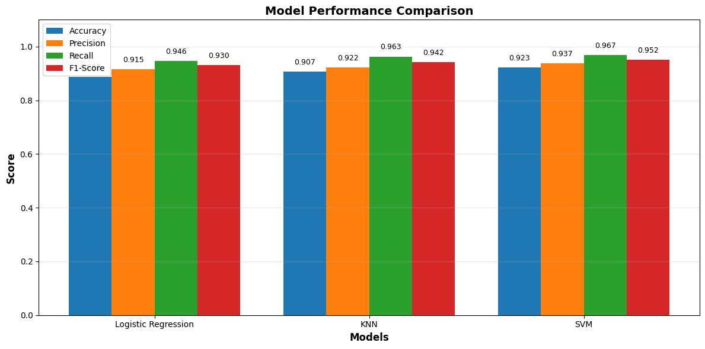
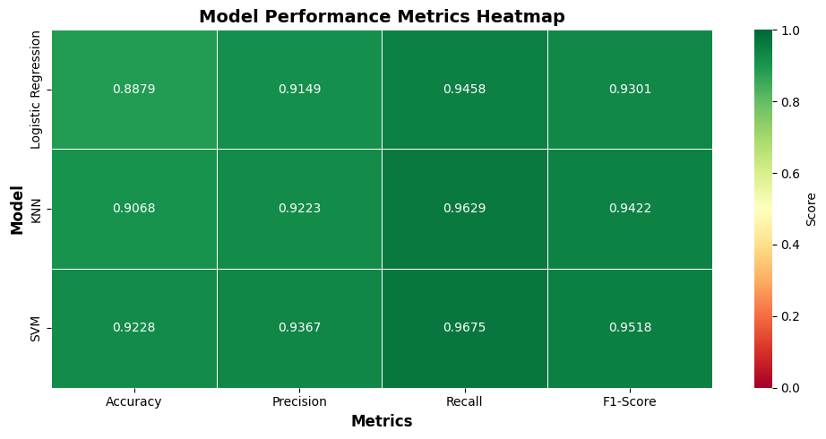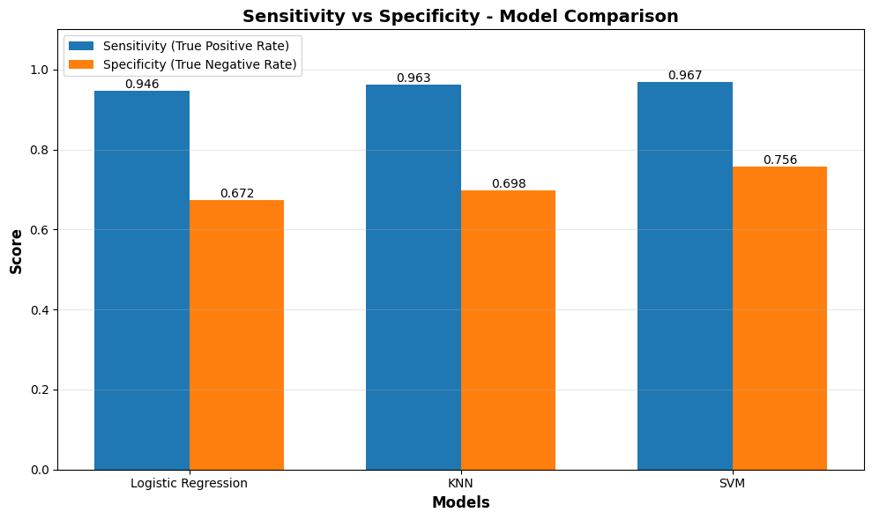

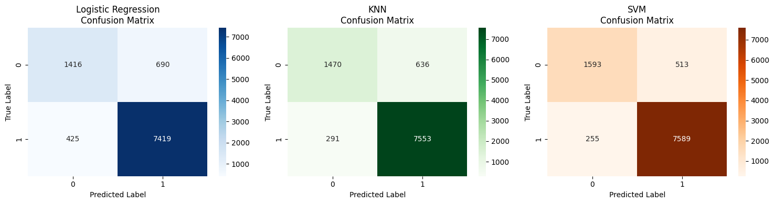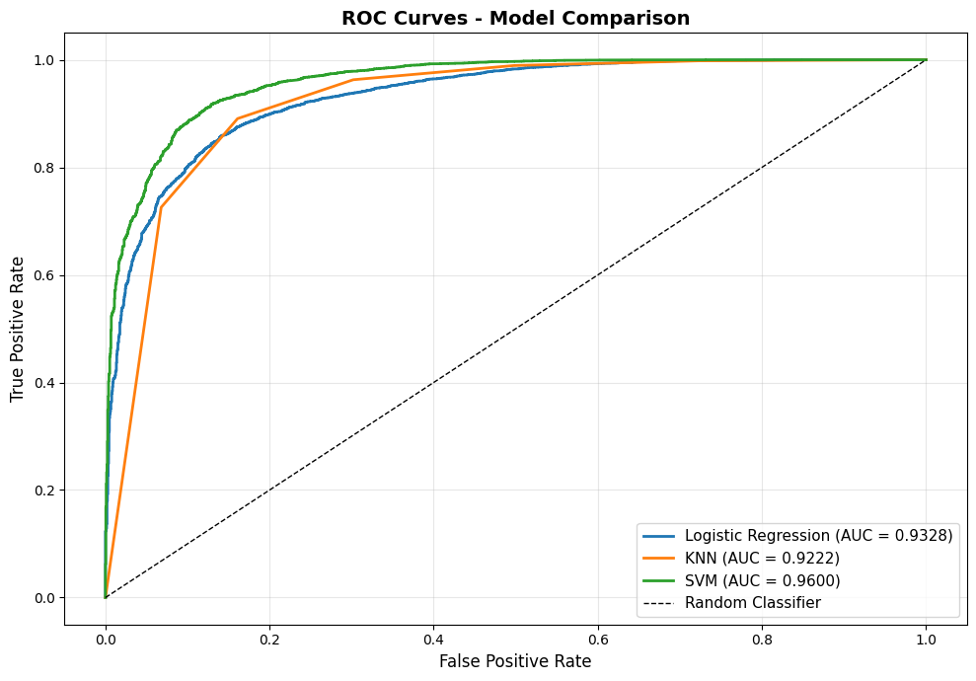

- Conclusion and Future Scope:

The project successfully developed a machine learning system to predict heart disease using patient data. Data preprocessing and feature engineering significantly improved model performance.
Conclusion:
- Logistic Regression provided interpretable results.
- KNN and SVM improved prediction robustness.
- Proper preprocessing was critical for accuracy.
Future Scope:
- Use larger and real-time datasets
- Implement deep learning models for better accuracy
- Deploy the model as a web or mobile application
- Integrate with healthcare systems for real-time prediction

7. References:
Books:
- Let Us Python – Yashavant Kanetkar

Online Resources:
  - GeeksforGeeks – https://www.geeksforgeeks.org/
  - TutorialsPoint – https://www.tutorialspoint.com/cprogramming/index.htm
  - Stack Overflow – https://stackoverflow.com

